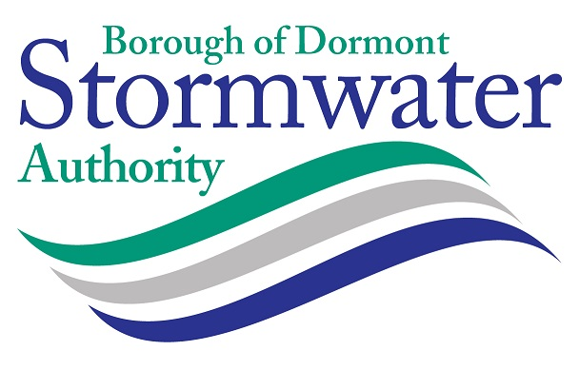

MINUTES OF THE REGULAR BUSINESS MEETING OF THE BOROUGH OF DORMONT STORMWATER AUTHORITY
HELD ON WEDNESDAY SEPTEMBER 20, 2023 6:00 PM

DORMONT MUNICIPAL BUILDING - 1444 HILLSDALE AVENUE DORMONT COUNCIL CHAMBERS
WITH VIRTUAL MEETING VIA ZOOM (Optional)

Call to Order: Meeting called to order by Frank Stumpo, Chairperson at 6:09pm.

Pledge of Allegiance was recited by all present.

Roll Call: The following members of the Board were in attendance:

Present: Frank Stumpo, Chairperson
James Mastronie, Vice-Chairperson

Absent: Jennifer Nolan-Kremm, Treasurer
Rosey Kipp (Via Zoom)

Also Present: Deborah Grass – Manager
Tricia Levander – Finance Officer
Alexis Wheeler – Solicitor
John Heyl, Engineer- LSSE

A quorum of the Board was not present – no official actions were taken.

Members of the Public Present: None

Comments from the Chairman: No comments from the Chairperson

Comments from the Public: None

Treasurers Report: Chairman Frank Stumpo reported that current collections for the month of August were $7,621.44; delinquent collections were $2127.25; the balance in the PLGIT Operating Account as of August 31 was $843,324.67. The bill list is in the amount of $20,732.10. The total collection rate through August 31 is 83%.

Engineer's Report: John Heyl, LSSE, reported that the annual MS4 report was reviewed with the Manager and will be submitted to DEP by the September 30 date. A grant application for the GEDTF program will be submitted before the September 22 deadline. Bids for the Piedmont Avenue project will be opened on October 11, 2023. The inlet cleaning project is ongoing. The Texas Avenue tank was inspected – report included.

Solicitor Report: The Solicitor reported that she would like to have a discussion with the Board in Executive Session about a pending complaint regarding a lien placed on property for unpaid sewer fees.

Manager's Report: Grass reported that she worked with the Solicitor regarding the lien complaint that can be discussed in Executive Session. A resolution was prepared for the GEDTF grant. The team renewed the Go Daddy domain name for emails and website and updated the cyber security policy. Much of the work this month was related to the residential tree program and the preparations for the Dormont Street Festival. Grass also submitted the Fall newsletter and attended the catch basin pre-construction meeting and a meeting with the Borough regarding a demolition project at the corner of Glenmore and the alley next to Eat ‘n Park.

Committee Reports:

Finance & Legal- No Report this month – staff are beginning to prepare the 2024 budget.

Education & Outreach – Grass provided an update on the residential tree program. Levander reviewed the prizes, raffle item, and details for the Street Festival which will be on October 14. DSWA has reserved a booth and is a sponsor for the event.

Consent Agenda:

No action could be taken on the consent agenda.

Action Items:

No action could be taken on agenda action items.

Discussion Items:

Grass updated the Board on the proposal by the Borough to eliminate dedicated office space and to assign flex-space at the Borough Building for the Authority.

Vacant Position – the Manager will continue to work with the Borough to identify new members for
appointment to the Board.

Comments from the Public – None

Adjournment: The Board members adjourned to Executive Session at 6:50pm.

Meeting was adjourned at 7:00 pm.

