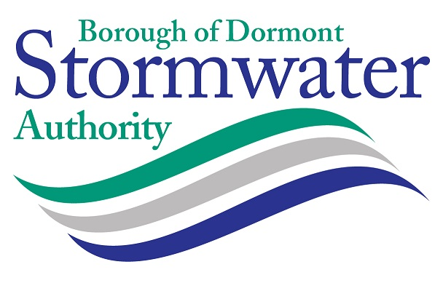

MINUTES OF THE REGULAR BUSINESS MEETING OF THE BOROUGH OF DORMONT STORMWATER AUTHORITY
HELD ON WEDNESDAY OCTOBER 18, 2023 6:00 PM

DORMONT MUNICIPAL BUILDING - 1444 HILLSDALE AVENUE DORMONT COUNCIL CHAMBERS
WITH VIRTUAL MEETING VIA ZOOM (Optional)

Call to Order: Meeting called to order by Frank Stumpo, Chairperson at 6:00pm.

Pledge of Allegiance was recited by all present.

Roll Call: The following members of the Board were in attendance:

Present: Frank Stumpo, Chairperson
James Mastronie, Vice-Chairperson
Jennifer Nolan-Kremm, Treasurer
Rosey Kipp

Also Present: Deborah Grass – Manager (via Zoom)
Tricia Levander – Finance Officer
Anthony Judice – Solicitor
John Heyl, Engineer- LSSE

Members of the Public Present: None

Comments from the Chairman: No comments from the Chairperson

Comments from the Public: None

Treasurers Report: Treasurer Jennifer Nolan-Kremm reported that current collections for the month of August were $1,386.52; delinquent collections were $3,738.84; the balance in the PLGIT Operating Account as of September 30 was $831,655.39. The bill list is in the amount of $16,876.89. The total collection rate through September 30 is 83%. Interest income with PLGIT is now almost $30,000.

Engineer's Report: John Heyl, LSSE, reported that the annual MS4 report was submitted to DEP by the September 30 date. Bids for the Piedmont Avenue project were opened on October 11, 2023 and the low bid was Niando Construction in the amount of $530,540 and it is recommended that the Board accept the bid – it is much lower than any of the other bids. It is also recommended that the Board add part of Phase 2 to the project since there are grant funds identified in the amount of $625,000. The catch basin/inlet cleaning project has been completed and the invoice has been provided to the Authority Manager.

Solicitor Report: The Solicitor reported that a review was completed for the cyber-security policy and comments were provided to the Authority Manager.

Manager's Report: Grass reported that the focus this month was on preparations for the street festival and the planning for the residential tree program. She and Tricia have begun the 2024 budget process and would like to schedule a Finance Committee meeting soon to review the preliminary numbers. She also attended a meeting with the Borough relative to the demolition of garages and the restoration of the site on Glenmore Avenue at Eastern Alley.

Committee Reports:

Finance & Legal- No Report this month – there will be a meeting held to review the budget.

Education & Outreach – Grass provided an update on the residential tree program. The Committee announced that the prize wheel and rubber duckies were a big draws for the crowd and the people who won the raffle were happy with the fall plants. The timeframe of 1pm – 5pm worked out well.

Consent Agenda:

Motion by Stumpo, second by Mastronie to approve the consent agenda:
- Meeting Minutes - August 16, 2023
- Meeting Minutes – Public Education & Outreach - September 7, 2023
- Meeting Minutes – September 20, 2023
- Bill List – September and October 2023
- Treasurer’s Report – September and October 2023
- Engineer’s Report – September and October 2023
- Manager’s Report – September and October 2023
- Payment – Invoices from Solicitor (September-October)
- Payment – Invoices from Engineer (September-October)
- Payment – Invoices from Manager (September-October)

Action Items:

- Motion by Stumpo, second by Nolan-Kremm to approve the LSSE Service Order Authorization (SOA) in the amount of $15,000 for the survey, design, and bidding services for the Espy Avenue Rain Garden project. (From September meeting)
Comments: None
Motion Approved: 4-0

- Motion by Stumpo, second by Mastronie to adopt Resolution No. 2023-2 requesting $250,000 through the Gaming Economic Development Tourism Fund (GEDTF) through the Redevelopment Authority of Allegheny County (RAAC). (From September meeting)
Comments: None
Motion Approved: 4-0

- Motion by Mastronie, second by Nolan-Kremm to adopt the Cyber-Security policy as drafted by the Authority Manager and reviewed by the Solicitor. (From September meeting)
Comments: None
Motion Approved: 4-0

- Motion by Nolan-Kremm, second by Stumpo to accept the low bid for the Piedmont Avenue Stormwater Improvement project Base Bid, Add Alternate No. 1 , 2, and 3 to Niando Construction, Inc. in the amount of $530,540.00, as recommended by the Engineer, subject to submission of the required bonds and review by the Solicitor.
Comments: None
Motion Approved: 4-0

- Motion by Stumpo, second by Mastronie to authorize payment in the amount of $16,500 to State Pipe Services, Inc. for the catch basin cleaning project as recommended by the Engineer.
Comments: None
Motion Approved: 4-0

Discussion Items:

Grass updated the Board on the proposal by the Borough to eliminate dedicated office space and to assign flex-space at the Borough Building for the Authority.

Vacant Position – the cover letter and resume from James Olchowski have been forwarded to the Borough Manager for Council consideration. A vote is scheduled for November 6.

Comments from the Public – None

Adjournment: The Board members adjourned to Executive Session at 6:25pm to review a matter of litigation with the Solicitor.

Meeting was adjourned at 6:31 pm.

