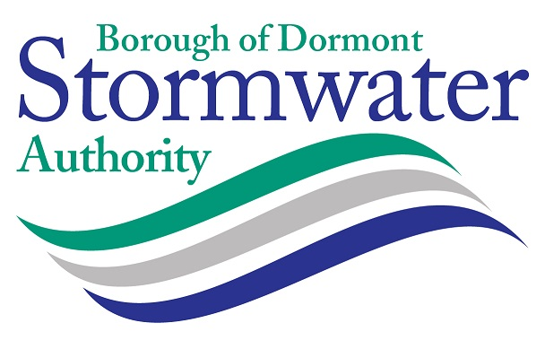

MINUTES OF THE REGULAR BUSINESS MEETING OF THE BOROUGH OF DORMONT STORMWATER AUTHORITY
HELD ON WEDNESDAY FEBRUARY 21, 2024 6:00 PM

DORMONT MUNICIPAL BUILDING - 1444 HILLSDALE AVENUE DORMONT COUNCIL CHAMBERS
WITH VIRTUAL MEETING VIA ZOOM (Optional)

Call to Order: Meeting called to order by the Chairman Frank Stumpo at 6:00pm.

Roll Call: The following members of the Board were in attendance:

Present: Frank Stumpo, Chairperson (current)
James Mastronie, Vice-Chairperson (current)
Jennifer Nolan-Kremm, Treasurer (current)
Rosey Kipp, Board Member
James Olchowski, Board Member

Also Present: Deborah Grass – Manager (Virtual)
Tricia Levander – Finance Officer, On-Site
Alexis Wheeler – Solicitor (Virtual)
John Heyl, Engineer- LSSE (Virtual)

Members of the Public Present: None

Comments from the Solicitor: The Solicitor stated that she can facilitate the Board elections.

Election of Officers
After discussion among members, there was a Motion by Mastronie, second by Nolan-Kremm to install the following slate of officers:

Jennifier Nolan Kremm, Chairperson
Frank Stumpo, Vice-Chairperson
James Mastronie, Treasurer
Rosie Kipp, Secretary

Public Comments – None
Motion Carried – 5-0

Committee Assignments:

Motion by Kipp, second by Mastronie, to appoint Jennifer Nolan-Kremm and James Mastronie to the Finance and Legal Committee.
Motion by Stumpo, second by Mastronie to appoint Rosie Kipp and James Olchowski to the Education and Public Outreach Committee.

Public Comments - None
Motion Carried – 5-0

Comments from the Public: None

Treasurers Report: Treasurer Mastronie reported that current collections for the month of January were $141,903.64; delinquent collections were $2,364.90; the balance in the PLGIT Operating Account as of January 31 was $941,948.15. The bill list is in the amount of $30,678.01. The total collection rate through January 31 is 37.1%. Interest income with PLGIT for 2023 was over $38,000.

Engineer's Report: John Heyl, LSSE, reported that the DEP inspection on January 30 went well – there were no comments or findings. Piedmont Avenue is moving along – work is resuming and should be completed by April; bids were opened on February 19 for the Piedmont Avenue Phase 2 project and the low bidder was Niando Construction – it is recommended to accept the low bid at tonight’s meeting. The Espy rain garden bid was also opened and it is recommended to award to the low bidder All-Phase 2 Site Contracting. The Small Sewer and Water grant was awarded in the amount of $200,000 for the Dormont Park TMDL project. The LSA grant was submitted and awards have not been announced yet.

Solicitor Report: The Solicitor has been working on the easement agreement for the Espy Avenue rain garden project.

Manager's Report: Grass reported that the contracts for the LSA and GEDTF projects are in the process of being executed with the state and county. Grass has updated the federal SAM registration. Levander scheduled the 2023 audit to begin in March and is downloading information for the auditors. Grass submitted the Spring newsletter article to the Borough. Grass prepared material and attended the DEP inspection. Grass is working with DCED to execute the Small Water and Sewer grant. Grass reviewed and obtained signatures for the NPDES permit renewal. Grass downloaded all bid documents and grant contracts to the digital files.

Committee Reports:

Finance & Legal- No Report

Education & Outreach – No Report

Consent Agenda:

Motion by Stumpo, second by Mastronie to approve the consent agenda:
- Meeting Minutes – January 17, 2024
- Bill List – February 2024
- Treasurer’s Report – February 2024
- Engineer’s Report – February 2024
- Manager’s Report – February 2024

- Payment – Invoices from Solicitor (February 2024)
- Payment – Invoices from Engineer (February 2024)
- Payment – Invoices from Manager (February 2024)

Public Comments: None
Motion Approved: 5-0

Action Items:

- Motion by Mastronie, second by Kipp to award the contract to low bidder Niando Construction, Inc. in the amount of base bid $245,500 and alternate $49,450 for the Piedmont Avenue Phase 2 project to be partially funded by the GEDTF-2022-170 grant as recommended by the Engineer.
Comments: None
Motion Approved: 5-0

- Motion by Kipp, second by Mastronie to award the contract to low bidder All-Phase 2 Site Contracting in the amount of $70,382.00 for the Espy Avenue Rain Garden Project as recommended by the Engineer.
Comments: None
Motion Approved: 5-0

- Motion by Stumpo, second by Mastronie to authorize the Authority officials to sign the easement agreement with the Borough for the Espy Avenue rain garden.
Comments: None
Motion Approved: 5-0

- Motion by Stumpo, second by Kipp to authorize Authority officials to sign the contract documents for the Small Water and Sewer Grant in the amount of $200,000 for the Dormont Park TMDL Project.
Comments: None
Motion Approved: 5-0

Discussion Items:

The Manager and Engineer discussed a complaint that was addressed at 2910 Crosby Avenue about pooling flood water because catch basins have collapsed. The Engineer will look into this repair with a contractor.

The Manager and Engineer discussed catch basins that are failing on McFarland Road – this has been reported to PENNDOT.

The Manager identified two training opportunities in April – anyone wishing to attend should notify the Manager and she will make reservations.

Comments from the Public – None

Adjournment: Motion by Kipp, second by Mastronie to adjourn the meeting at 7:05pm.

